Software Engineering Report

SID:

**MOD003263**

**Submitted: December 2022**

**Table of Contents**

**Introduction** 3

**1.** **Problem Definition Document** 4

1.1 Definition of aims 4

1.2 System Requirements 4

1.3 Software Used 4

1.4 User Stories 4

**2.** **Software Design** 5

2.1 Wireframe 5

2.2 Database Design 8

**2.2.1 Entity Relationship Diagram** 8

**2.2.2 Extended Entity Relationship Diagram** 9

**2.2.3 Table Schema** 9

2.3 Software Design 12

**2.3.1 Use Case Diagram** 12

**2.3.2 Class Diagram** 16

**2.3.3** **Sequence Diagram** 16

**Software Development Documentation** 18

Add Idea(Linked with Author user story 1): 19

Ideas(Linked with Relationship manager user story 6 and Author user story 2): 22

Extra comments 26

**Testing** 26

**Plan of the Software Maintenance** 28

**Conclusions** 30

# **Introduction**

This Report shows an overview of the work that I and my team has done to complete the project. Everything submitted in this report is the same as the other people who worked on this project except: Database descriptions, Introduction, Conclusion, Software development and testing. Further down the whole application structure is shown, from wireframing and database designs to actual code.

# **Problem Definition Document**

## **1.1 Definition of aims**

This project aim is to create a software application for Citisofts that allows employees to store ideas that their clients can invest. Also, the employees can have the list of all the ideas and the contact of their clients so they can contact them for the possible new investment.

## **1.2 System Requirements**

The mains system requirements needed to handle the following software application are:

1. PC running Windows 7 or later versions.

2. Keyboard and mouse to be able to write and interact with the application and the Graphical User Interface, GUI.

## **1.3 Software Used**

The software used by the team to complete this project are:

* Lucidchart
* Google Chrome web browser
* Microsoft Word
* Microsoft Teams
* GitHub
* Visual Studio 2019

## **1.4 User Stories**

After reading the case study, the User Stories that was possible to get are:

Relationship Manager, RM:

1. As a RM, I want to be able to log in so that I can access all the information.
2. As a RM, I want to reset my forgotten password so that I can access my account.
3. As a RM, I want to change my account details so that my clients can always reach me.
4. As a RM, I want to access the client list so that I can view all the clients enrolled in the database.
5. As a RM, I want to access the client information so that I can contact them about available opportunities.
6. As a RM, I want to access all the investment ideas so that I can pitch it to prospective clients.
7. As a RM, I want to see the tags for ideas and investments so that I can present the most suitable one’s for my clients.
8. As a RM, I want to be able to see only relevant ideas so that I don’t pitch my clients expired ideas.
9. As a RM, I want to be able to edit client details so that the database remains up to date.
10. As a RM, I want to be able to add new clients so that the organisation can achieve growth.
11. As a RM, I want to be able to search for clients so that I can pitch a relevant idea to them.
12. As a RM, I want to be able to search for ideas so that I can match them to the relevant client.
13. As a RM, I want to be able to search for products so that I can provide the relevant client information about the idea it belongs to.

Author Ideas, AI:

1. As an author, I want to be able to add new ideas so that the RM can pitch them to his/her clients in time.
2. As an author, I want to access the list of all the ideas so that I can view what other authors in the organisation have posted.
3. As an author, I want to be able to reset my forgotten password so that I can access my account for timely posting of ideas.
4. As an author, I want to be able to change my account details so that I can always be reached within the organisation.
5. As an author, I want to be able to set expiry dates on ideas so that they are displayed only till they remain relevant opportunities.
6. As an author, I want to be able to add to add relevant information about the ideas so that the RM can confidently convey them to his/her clients.

# **Software Design**

## **2.1 Wireframe**

Figure 1 – Login Wireframe

Figure 2 – RM Wireframe

Figure 3 – AI Wireframe

## **2.2 Database Design**

### **2.2.1 Entity Relationship Diagram**

Figure 4 – Entity Relationship Diagram

### **2.2.2 Extended Entity Relationship Diagram**

Figure 5 – Extended Entity Relationship Diagram

### **2.2.3 Table Schema**

|  |  |  |  |
| --- | --- | --- | --- |
|  |  | **Accounts Table** |  |
| **Name of the field** | **Data Type** | **Allow Nulls** | **Description** |
| Employee ID | int | No | Primary key of the database |
| Name | varchar(50) | No | Holds the Name of the certain Account |
| Surname | varchar(50) | No | Holds the Surname of the certain Account |
| Email | varchar(50) | No | Holds the Email of the certain Account |
| Password | varchar(MAX) | No | Holds the Password of the certain Account |
| Role | varchar(50) | No | Holds the Role of the certain Account |
| Phone number | varchar(50) | No | Holds the Phone number of the certain Account |
| Employee photo | image | Yes | Holds the Employee photo of the certain Account |

|  |  |  |  |
| --- | --- | --- | --- |
|  |  | **Ideas Table** |  |
| **Name of the field** | **Data Type** | **Allow Nulls** | **Description** |
| Idea_ID | int | No | Primary key of the database |
| Title | varchar(50) | No | Holds the Title of the certain idea |
| Abstract | varchar(50) | No | Holds the Abstract of the certain idea |
| Publish_date | int | No | Holds the Publish_date of the certain idea |
| Expiry_date | int | No | Holds the Expiry_date of the certain idea |
| Author | varchar(50) | No | Holds the Author of the certain idea |
| Content | varchar(MAX) | No | Holds the Content of the certain idea |
| Risk_rating | int | No | Holds the Risk_rating of the certain idea |
| Product_type | varchar(50) | No | Holds the Product_type of the certain idea |
| Instrument | varchar(50) | No | Holds the Instrument of the certain idea |
| Currency | varchar(50) | No | Holds the Currency of the certain idea |
| Major_sector | varchar(50) | No | Holds the Major_sector of the certain idea |
| Minor_sector | varchar(50) | No | Holds the Minor_sector of the certain idea |
| Region | varchar(50) | No | Holds the Region of the certain idea |
| Country | varchar(50) | No | Holds the Country of the certain idea |

|  |  |  |  |
| --- | --- | --- | --- |
|  |  | **Client Table** |  |
| **Name of the field** | **Data Type** | **Allow Nulls** | **Description** |
| Client ID | int | No | Primary key of the database |
| Name | varchar(50) | No | Holds the Name of the certain Client |
| Surname | varchar(50) | No | Holds the Surname of the certain Client |
| Portfolio | varchar(50) | No | Holds the Portfolio of the certain Client |
| Email | varchar(50) | No | Holds the Email of the certain Client |
| PhoneNumber | varchar(50) | No | Holds the PhoneNumber of the certain Client |
| RiskPreference | varchar(50) | No | Holds the RiskPreference of the certain Client |
| Region | varchar(50) | No | Holds the Region of the certain Client |
| Country | varchar(50) | No | Holds the Country of the certain Client |

|  |  |  |  |
| --- | --- | --- | --- |
|  |  | **Registration** |  |
| **Name of the field** | **Data Type** | **Allow Nulls** | **Description** |
| Registeration ID | int | No | Primary key of the database |
| Name | varchar(50) | No | Holds the Name of the new Client |
| Surname | varchar(50) | No | Holds the Surname of the new Client |
| Email | varchar(50) | No | Holds the Email of the new Client |
| Phone number | int | No | Holds the Phone number of the new Client |
| Region | varchar(50) | No | Holds the Region of the new Client |
| Country | varchar(50) | No | Holds the Country of the new Client |
| Risk preference | nchar(10) | No | Holds the Risk preference of the new Client |

## **2.3** **Software Design**

### **2.3.1 Use Case Diagram**

Figure 6 – UML Use Case Diagram

|  |  |
| --- | --- |
| Use Case Name | View Clients |
| Participating Actors | Relationship Manager |
| Flow of Events | 1. User clicks “Display” 2. Users in the database display 3. User enters the attributes for the client he wants to search 4. User / Users with the attributes entered display |
| Alternative Flows | a1. User enters attributes that do not exist  a2. No output Displayed  b1. The step 1 from flow of events is skipped.  c1. The input is too big (error)  d1. The user does nothing |
| Entry Conditions | User is in Client list |
| Exit Conditions | User clicks on another page |

|  |  |
| --- | --- |
| Use Case Name | Add Clients |
| Participating Actors | Relationship Manager |
| Flow of Events | 1. User enters all the details for the client 2. Users clicks save 3. A message saying “successfully uploaded” pops up and the attributes are added in the database |
| Alternative Flows | a1. The user does nothing |
| Entry Conditions | User is in Registration page |
| Exit Conditions | User clicks on another page |

|  |  |
| --- | --- |
| Use Case Name | Login |
| Participating Actors | Relationship Manager / Author |
| Flow of Events | 1. User adds Email and Password 2. User clicks Login 3. Login is successful and the user is prompted to the corresponding page (RM/AU) |
| Alternative Flows | a1. User Clicks forgot my password  a2. Prompted to “forgot my password” page  b1. User does nothing  c1. User enters wrong Email / Password  c2. Wrong credentials error message pops up. |
| Entry Conditions | User has credentials |
| Exit Conditions | User Enters the right credentials and clicks log in or closes the application |

|  |  |
| --- | --- |
| Use Case Name | View Ideas |
| Participating Actors | Relationship Manager / Author |
| Flow of Events | 1. User clicks Show Ideas 2. All the ideas are displayed |
| Alternative Flows | a1. User does nothing |
| Entry Conditions | User is in Ideas page |
| Exit Conditions | User clicks on another page |

|  |  |
| --- | --- |
| Use Case Name | Add Ideas |
| Participating Actors | Author |
| Flow of Events | 1. User Enters all the attributes 2. User clicks the “ADD” button 3. The idea is added and also followed by a message. |
| Alternative Flows | a1. User does not enter all the attributes  a2. User clicks the “ADD” button  a3. Error pops up  b1. User does nothing |
| Entry Conditions | User is in Add idea page |
| Exit Conditions | User clicks on another page |

### **2.3.2 Class Diagram**

Figure 7 – Class Diagram

### **Sequence Diagram**

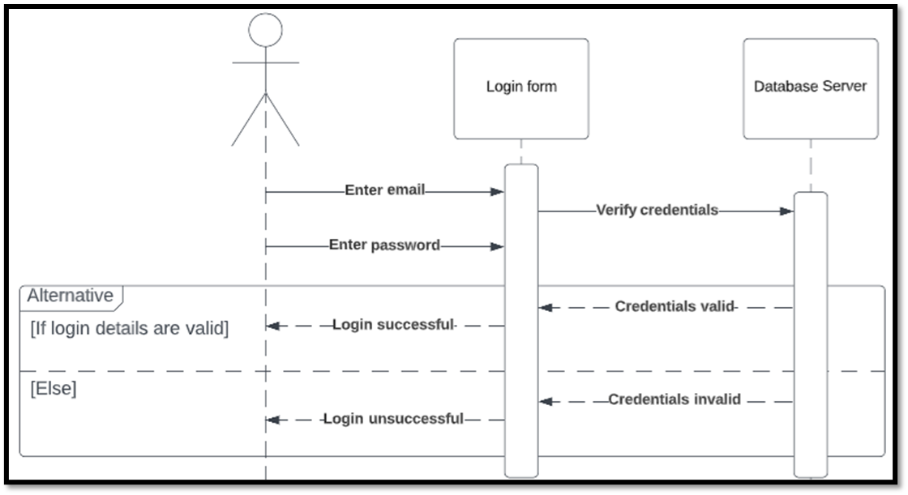

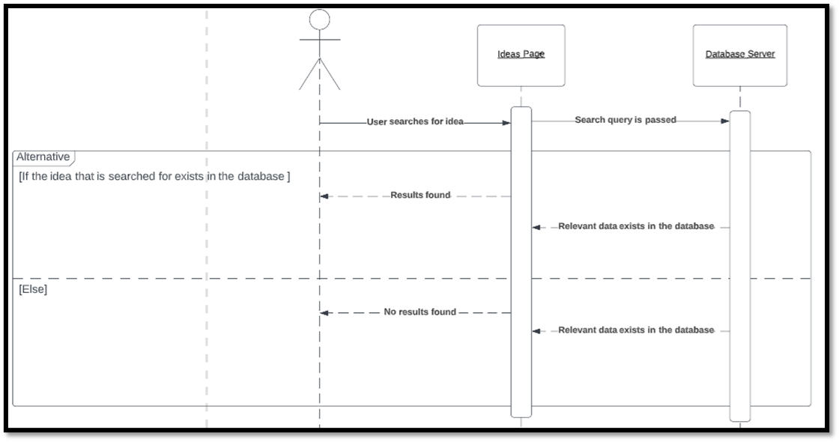

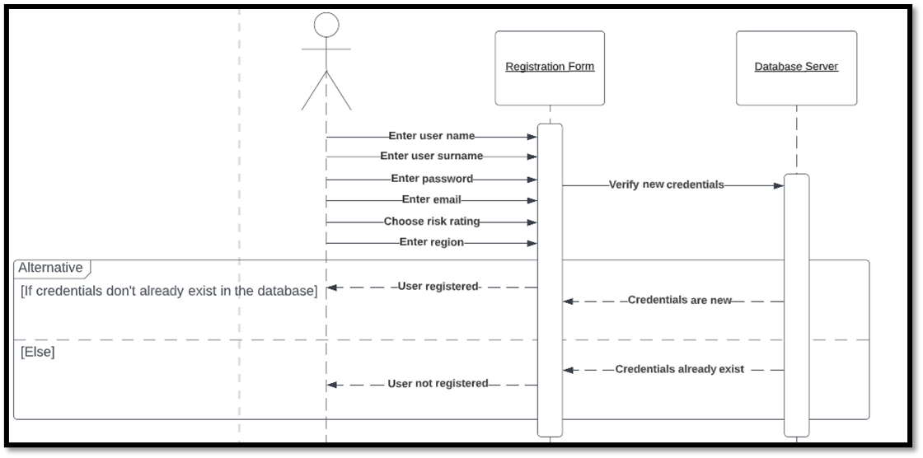

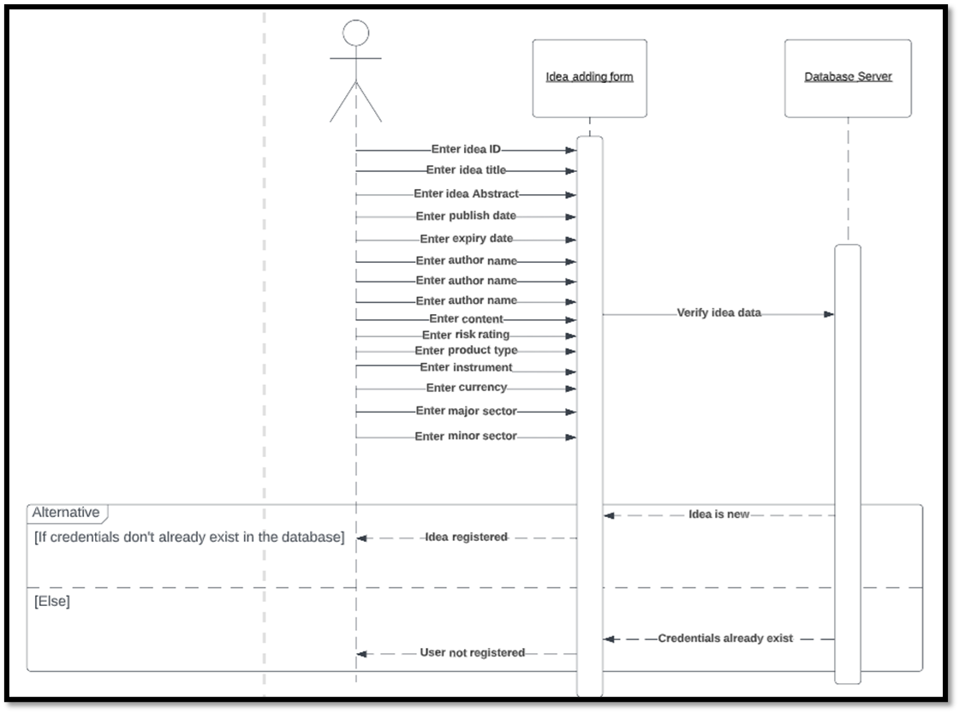

# **Software Development Documentation**

## Add Idea(Linked with Author user story 1):

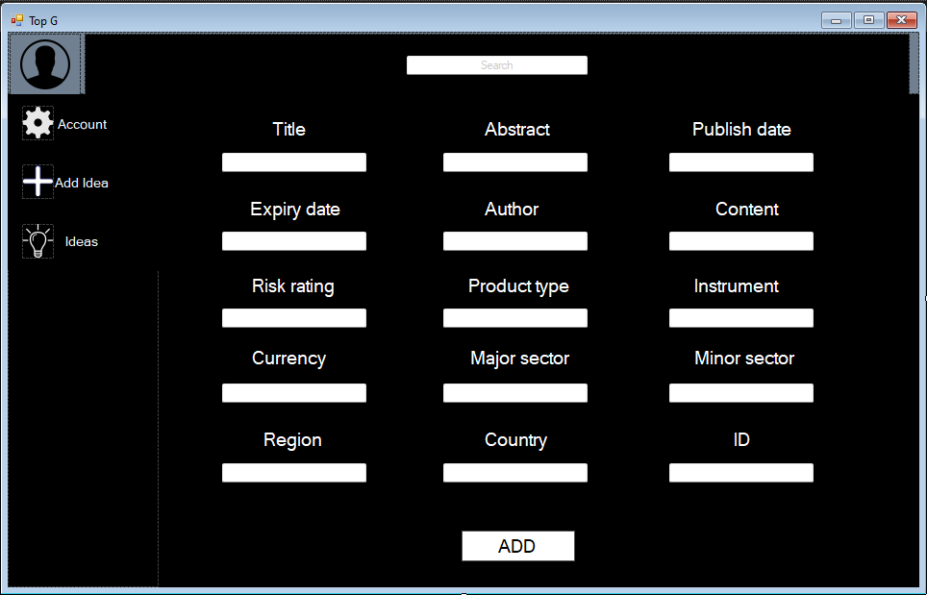

This is the page where the author will add new ideas. A simple dark background has been added for simplicity and above it all the input boxes are visible accompanied by textboxes that explain what needs to be added inside each one. Lastly, the “ADD” button has been added so the user can submit the idea by clicking “ADD”.

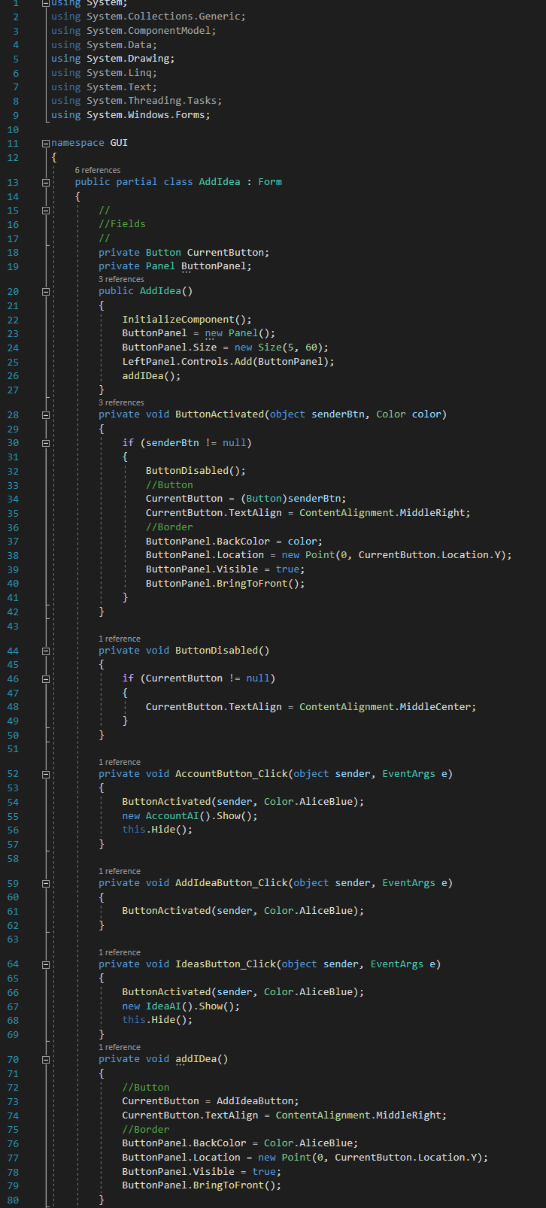

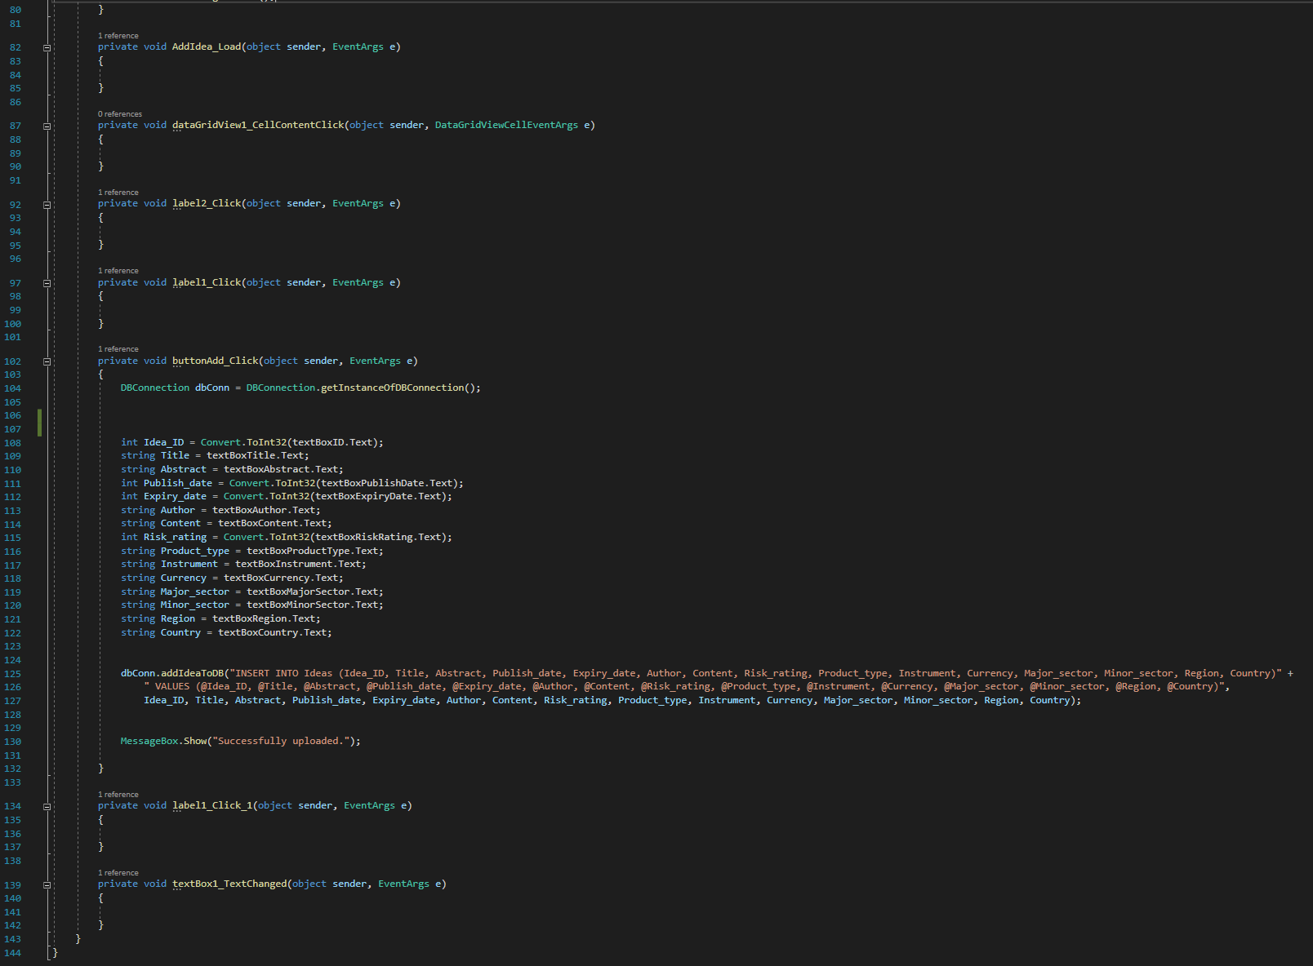

The two screenshots above show the code behind “Add Idea”. The buttons “AddIdeaButton_Click” and AccountButton_Click are added for navigation purposes between the pages. The “buttonAdd_Click” is the button that adds all the information stored at the inputs inside the database. More specifically, all the attributes are being defined and the strings are also converted so they can be added inside the SQL query.

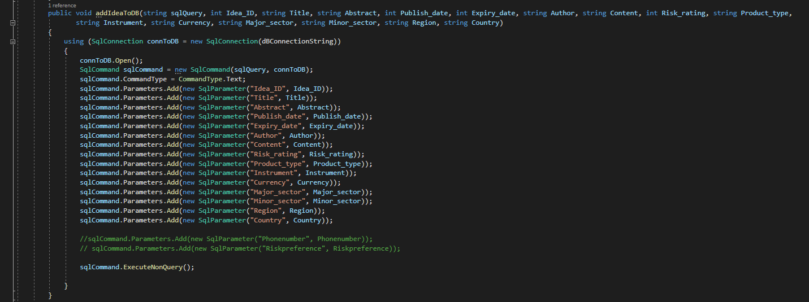

Lastly this is the code that is connecting the AddIdea with the database (Class name: DBConnection).

## Ideas(Linked with Relationship manager user story 6 and Author user story 2):

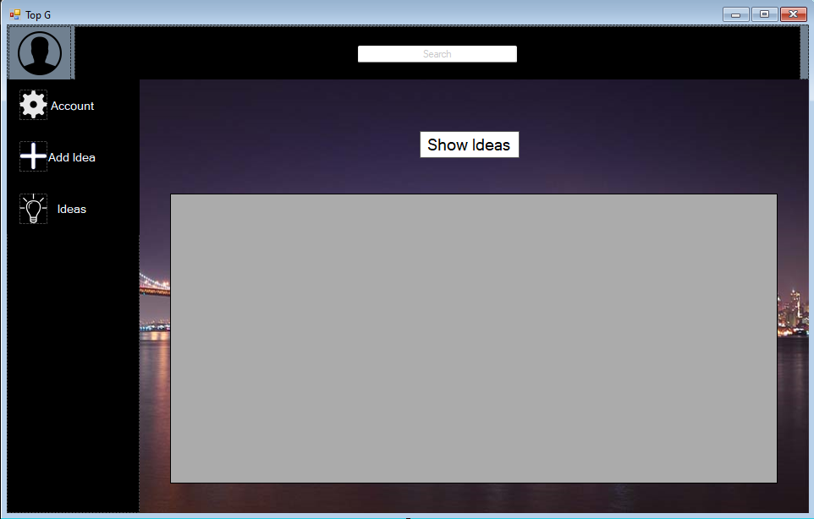

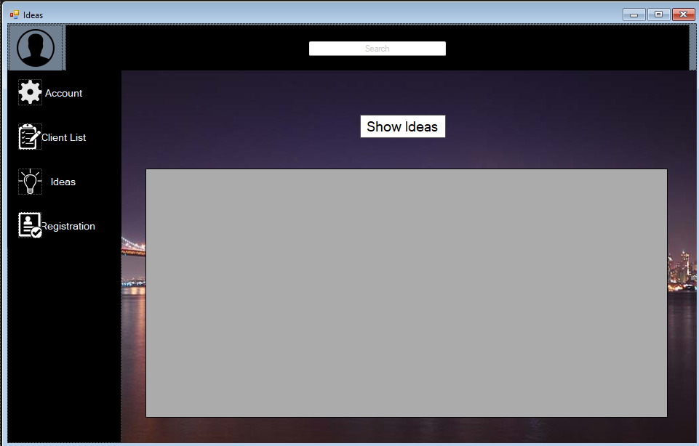

These are the pages where both the author and the relationship manager can view the Ideas list. A box where all the results from the database will be displayed has been added as well as a button that will display all the ideas when clicked by the user.

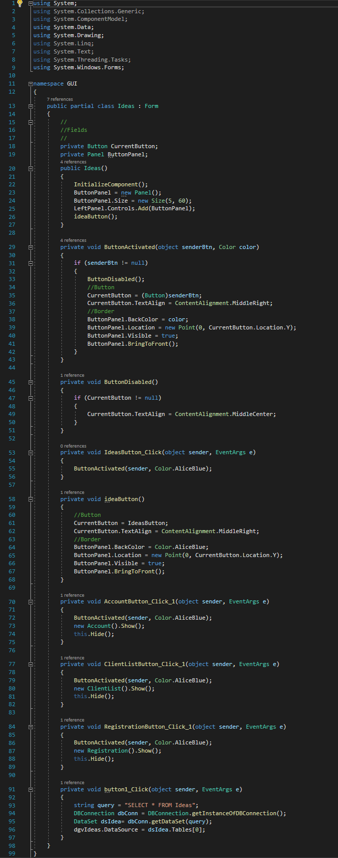

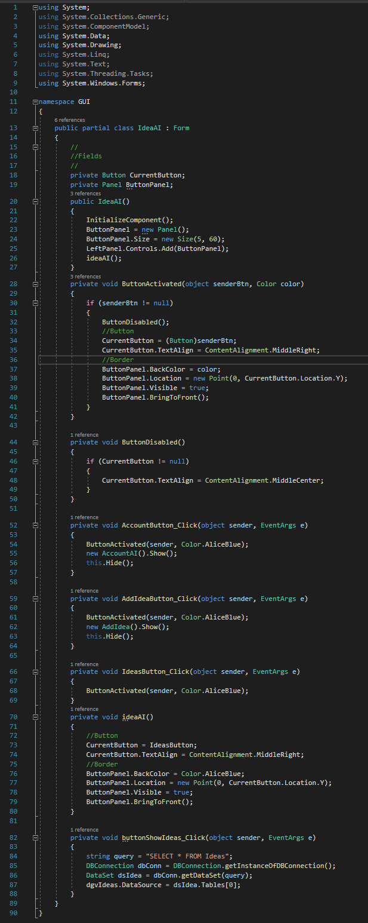

Same as before, “IdeasButton_Click”, “AccountButton_Click_1” and “AccountButton_Click”, “AddIdeaButton_Click”have been added for navigational purposes to the other pages for Relationship manager and Author respectively. At the bottom the code for displaying the ideas is visible (selects all the data from “Ideas” table and displays them to the user”

## Extra comments

It is also worth noting that for the AddIdea to work the database (Ideas) names had to be modified so there are no spaces between them because spaces where creating bugs.

# **Testing**

|  |  |  |  |  |  |  |
| --- | --- | --- | --- | --- | --- | --- |
| Test No | Test | Class | Test Method | Expected Job | Pass/Fail | Date |
| 1 | No credentials are added when logging in. | Login | Button_LoginButton_Click | Display “Your credentials don’t match. Email or password are wrong” | Pass | 12/12/2022 |
| 2 | No Email is added when logging in. | Login | Button_LoginButton_Click | Display “Your credentials don’t match. Email or password are wrong” | Pass | 12/12/2022 |
| 3 | No Password is added when logging in. | Login | Button_LoginButton_Click | Display “Your credentials don’t match. Email or password are wrong” | Pass | 12/12/2022 |
| 4 | Click forgot my password | Login | Button_ ForgotPasswordButton _Click | Display forgot password page | Pass | 12/12/2022 |
| 5 | Try to reset password | Login | No button | Reset password | Fail | 12/12/2022 |
| 6 | Enter valid credentials and pass the login phase(RM-AU) | Login | Button_LoginButton_Click | Display the next page (either RM or Author) | Pass | 12/12/2022 |
| 7 | Go to client list(RM) | Account | ClientListButton_Click | Navigate to the Account page | Pass | 12/12/2022 |
| 8 | Go to Ideas(RM) | ClientList | IdeasButton_Click | Navigate to the Ideas page | Pass | 12/12/2022 |
| 9 | Go to registration(RM) | Ideas | RegistrationButton_Click_1 | Navigate to registration page | Pass | 12/12/2022 |
| 10 | Click search button without any textboxes filled | ClientList | searchBtt_Click_1 | The program should not crash or display any information | Pass | 12/12/2022 |
| 11 | Click search button with valid information inside the textbox “Name” | ClientList | searchBtt_Click_1 | Display all the relevant information to the search | Pass | 12/12/2022 |
| 12 | Click search button with valid information inside the textbox “Surname” | ClientList | searchBtt_Click_1 | Display all the relevant information to the search | Pass | 12/12/2022 |
| 13 | Click search button with valid information inside the textbox “Portfolio” | ClientList | searchBtt_Click_1 | Display all the relevant information to the search | Pass | 12/12/2022 |
| 14 | Click search button with valid information inside the textbox “Email” | ClientList | searchBtt_Click_1 | Display all the relevant information to the search | Pass | 12/12/2022 |
| 15 | Click search button with valid information inside the textbox “Phone Number” | ClientList | searchBtt_Click_1 | Display all the relevant information to the search | Pass | 12/12/2022 |
| 16 | Click search button with valid information inside the textbox “Risk Reference” | ClientList | searchBtt_Click_1 | Display all the relevant information to the search | Pass | 12/12/2022 |
| 17 | Click search button with valid information inside the textbox “Region” | ClientList | searchBtt_Click_1 | Display all the relevant information to the search | Pass | 12/12/2022 |
| 18 | Click search button with valid information inside the textbox “Country” | ClientList | searchBtt_Click_1 | Display all the relevant information to the search | Pass | 12/12/2022 |
| 19 | Click Display button | ClientList | displayBtt_Click_1 | Display all the clients | Pass | 12/12/2022 |
| 20 | Click Show Ideas button | Ideas | button1_Click | Display all the ideas | Pass | 12/12/2022 |
| 21 | Click save without adding any of the attributes | Registration | button1_Click_1 | Saves a blank row in the database | Pass | 12/12/2022 |
| 22 | Click save and add all the attributes | Registration | button1_Click_1 | Saves a row in the database that contains all the information entered | Pass | 12/12/2022 |
| 23 | Click save and add “Name” | Registration | button1_Click_1 | Saves only the attribute added | Pass | 12/12/2022 |
| 24 | Click save and add “Surname” | Registration | button1_Click_1 | Saves only the attribute added | Pass | 12/12/2022 |
| 25 | Click save and add “E-Mail” | Registration | button1_Click_1 | Saves only the attribute added | Pass | 12/12/2022 |
| 26 | Click save and add “Portfolio” | Registration | button1_Click_1 | Saves only the attribute added | Pass | 12/12/2022 |
| 27 | Click save and add “Name” | Registration | button1_Click_1 | Saves only the attribute added | Pass | 12/12/2022 |
| 28 | Click save and add “Phone Number” | Registration | button1_Click_1 | Saves only the attribute added | Pass | 12/12/2022 |
| 29 | Click save and add “Risk Rating” | Registration | button1_Click_1 | Saves only the attribute added | Pass | 12/12/2022 |
| 30 | Click save and add “Region” | Registration | button1_Click_1 | Saves only the attribute added | Pass | 12/12/2022 |
| 31 | Click save and add “Country” | Registration | button1_Click_1 | Saves only the attribute added | Pass | 12/12/2022 |
| 32 | Go to add idea(AU) | AccountAI | AddIdeaButton_Click | Navigate to the Account page | Pass | 12/12/2022 |
| 33 | Go to Ideas(AU) | AddIdea | IdeasButton_Click | Navigate to Ideas page | Pass | 12/12/2022 |
| 34 | Click ADD without adding any of the attributes | AddIdea | buttonAdd_Click | Adds a blank row in the database | Pass | 12/12/2022 |
| 35 | Click ADD and add all of the attributes | AddIdea | buttonAdd_Click | Adds a row in the database that contains all the information entered | Pass | 12/12/2022 |
| 36 | Click ADD and not add all of the attributes | AddIdea | buttonAdd_Click | Does not add any of the attributes because all of them are required | Pass (The program crashes) | 12/12/2022 |
| 37 | Click Show Ideas | IdeaAI | buttonShowIdeas_Click | Shows All the ideas | Pass | 12/12/2022 |

# **Plan of the Software Maintenance**

The application has met all the requirements mentioned in the brief and just because it works doesn’t mean it can’t work better. Some bugs have come into light in the testing phase, and most have been fixed. But several improvements can be made to improve the working of an application:

1. The details to login are in the accounts table of the database, which even includes password. This can be made to be encrypted so that it is immune against threats and attacks.
2. To add the feature of forgot password will be beneficial for the users which includes a two-factor authentication making the application secure.
3. The search bar in the application right now is not function, since it is heavily code depended on and everyone was not experienced enough. So, including this feature will make it further increase the factor of user friendliness.
4. In client list and view ideas, to see all the information the user must slide a scroll bar to the side but making the rows and columns constant will make the output clear and easy to read.
5. The current application is made in windows form, so making an application for macOS will be necessary as it is the next most used OS after Windows.
6. The application is based on English and making a function where all the information can be accesses in different languages will be making the application usable internationally.
7. Adding a new tile called best matches to make AI understand the client’s portfolio and his past investment to match him with the best possible Idea.
8. The application lacks a Logout button. This is a must and should be added in the future.
9. If the client asks copy of the idea, there must be a way of exporting a particular idea into a file while removing the confidential information.
10. In terms of security, if the application is doing a DNS check if the location of using the application is outside the office, it should be informing the cyber security team.

# **Conclusions**

This application was challenging to create and required good collaboration and hard work. If there was more time and some luck (Because a group member left out of the blue) I am sure that as a team we could do even more. The outcome is good and works well. In my opinion this is a well done project.